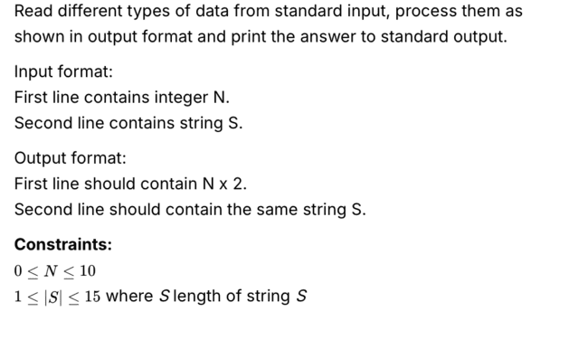

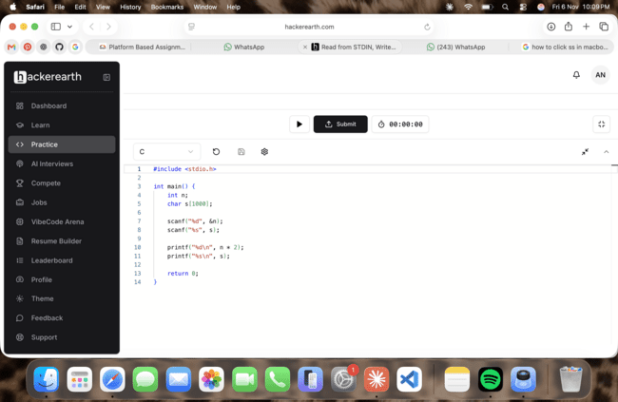

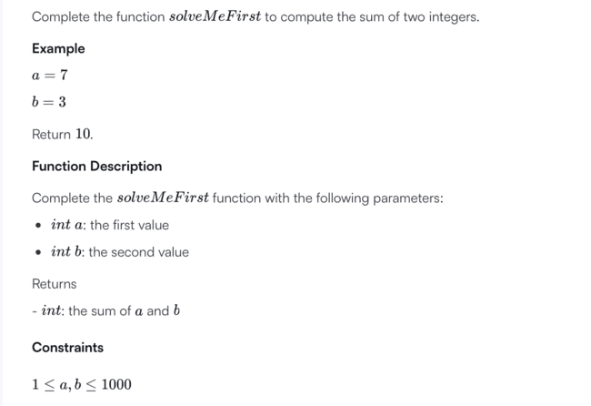

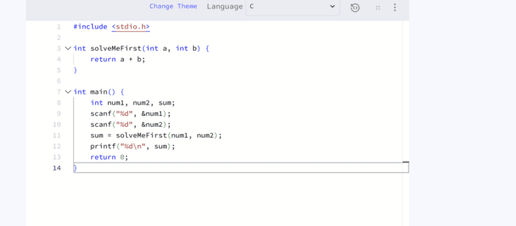
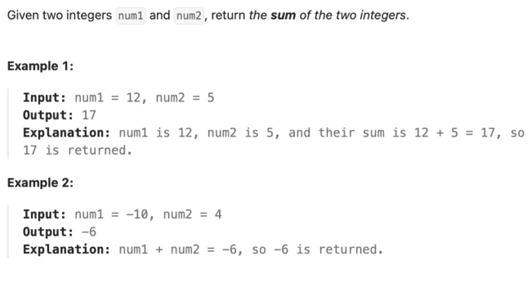
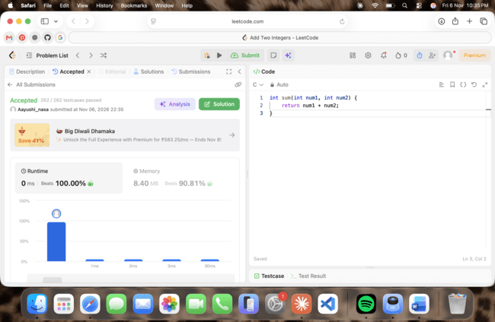

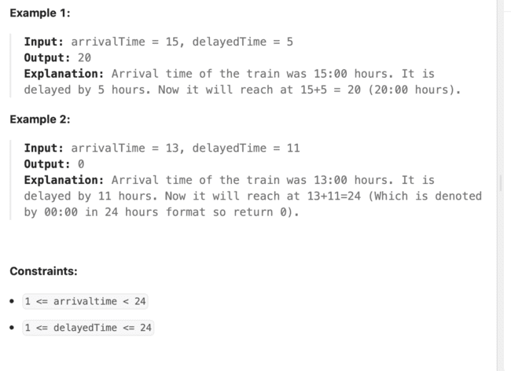
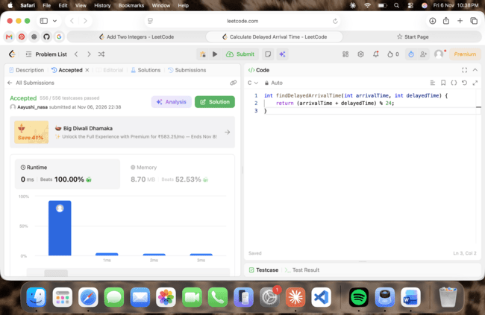
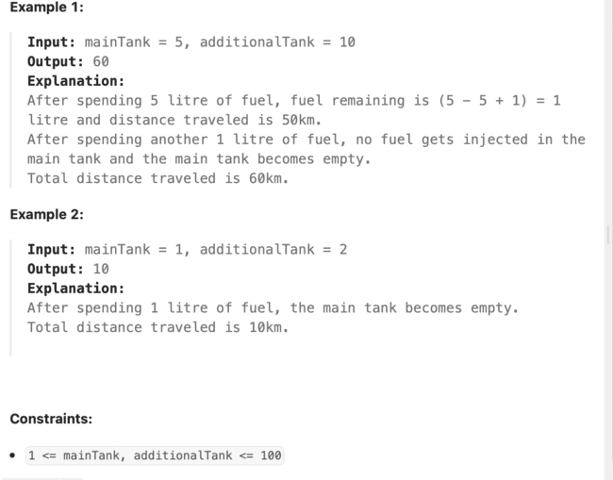
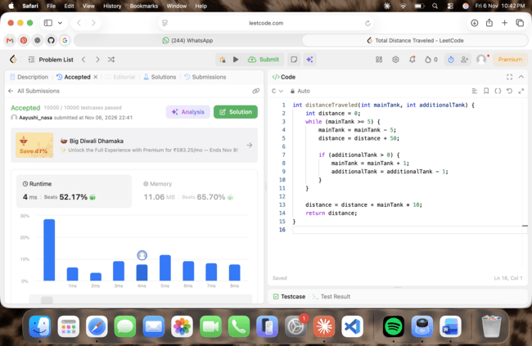
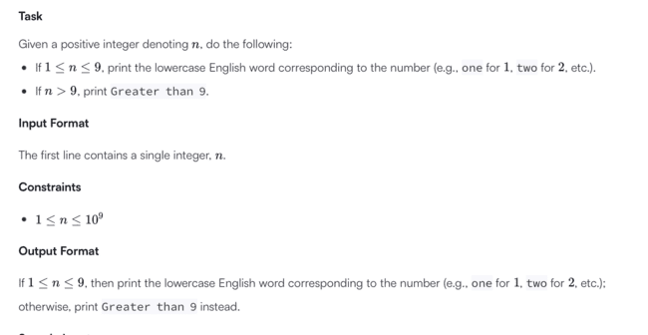
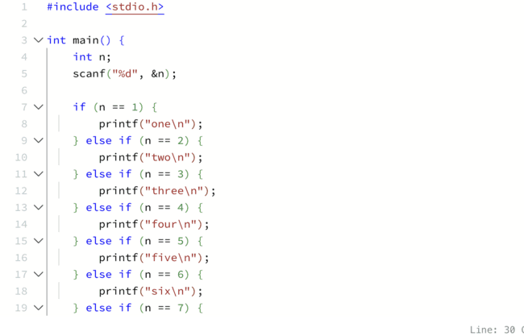
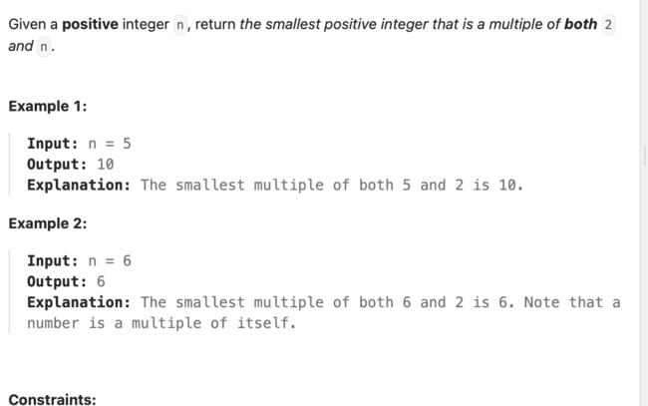
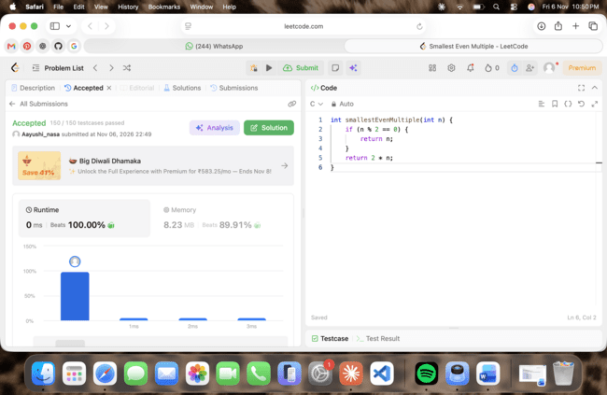

Question 8: Grading Students
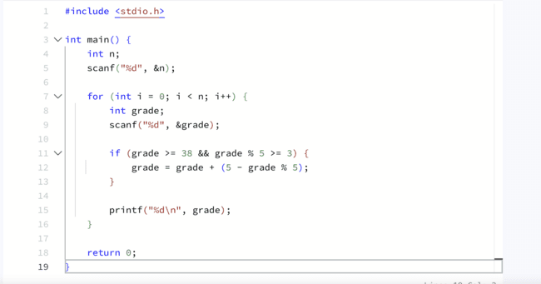

Question 9: Roy and Profile Picture
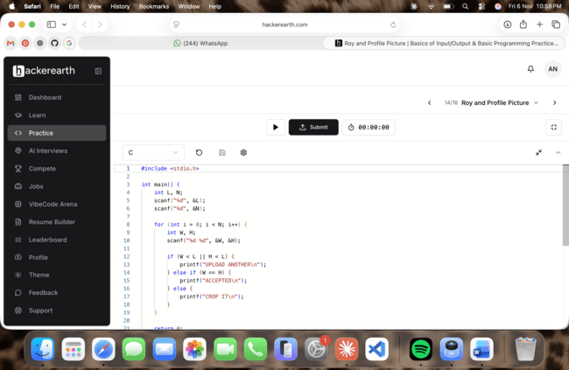

Question 10: FizzBuzz
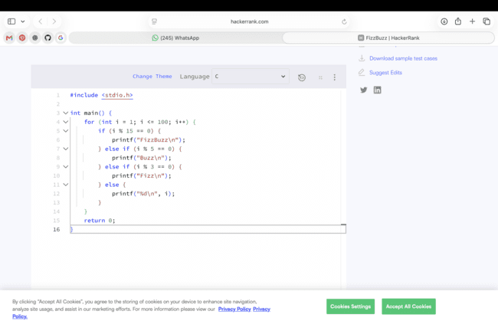

Question 11: For Loop in C (number to word, else even/odd)
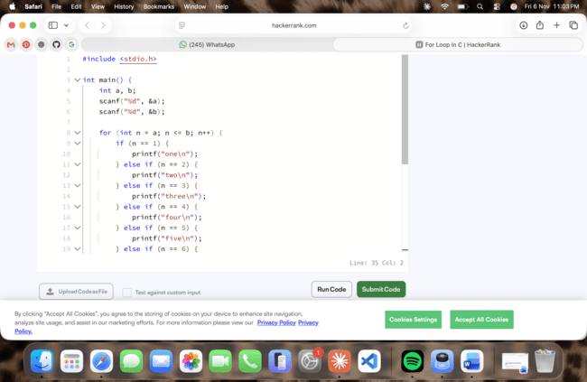
Question 12: 1342. Number of Steps to Reduce a Number to Zero
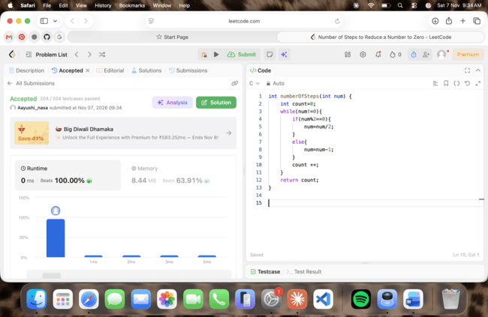

Question 13: 2169. Count Operations to Obtain Zero
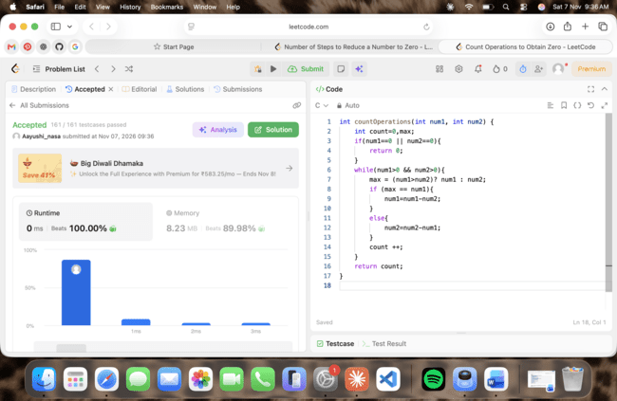
Question 14: 1523. Count Odd Numbers in an Interval Range
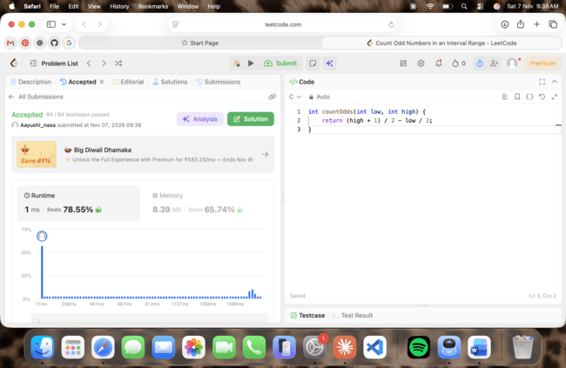

Question 15: 2652. Sum Multiples
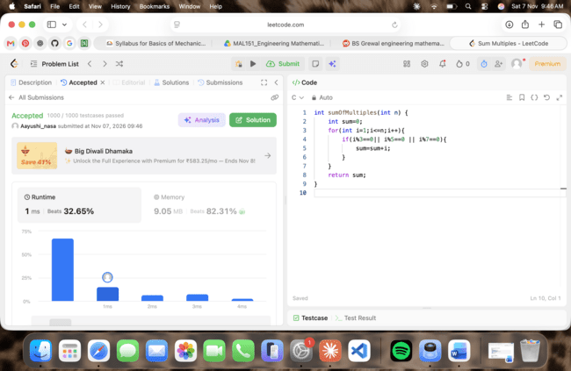

Question 16: Kangaroo
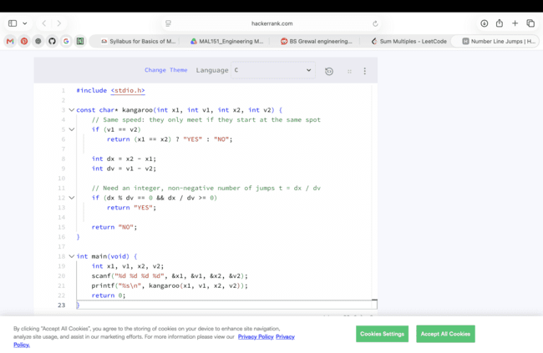

Question 17: Digit Sum
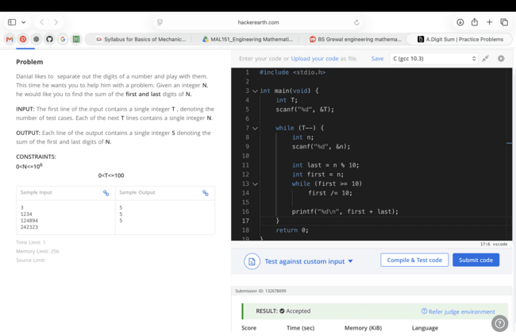

Question 18: Find Digits
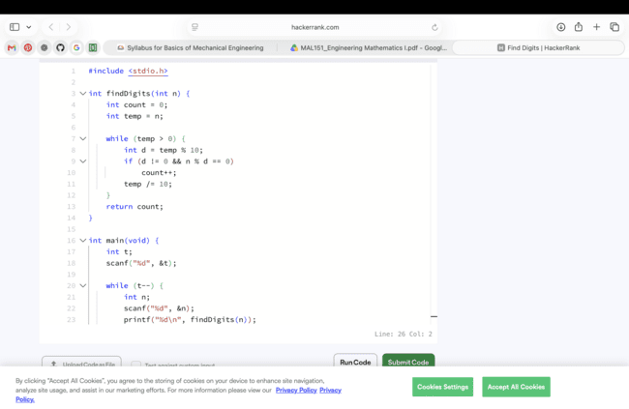

Question 19: 1281. Subtract the Product and Sum of Digits of an Integer
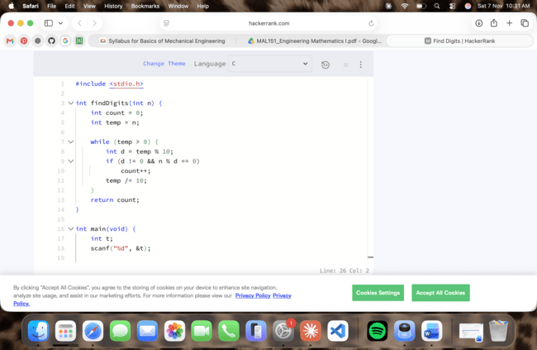

Question 20: 2520. Count the Digits That Divide a Number
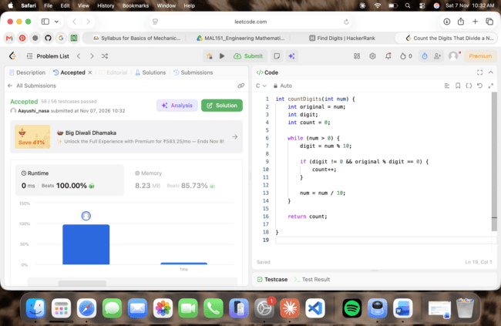

Question 21: 9. Palindrome Number
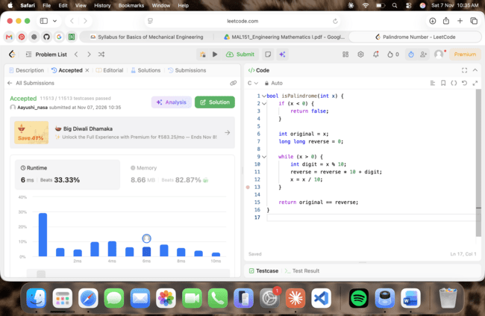

Question 22: 7. Reverse Integer
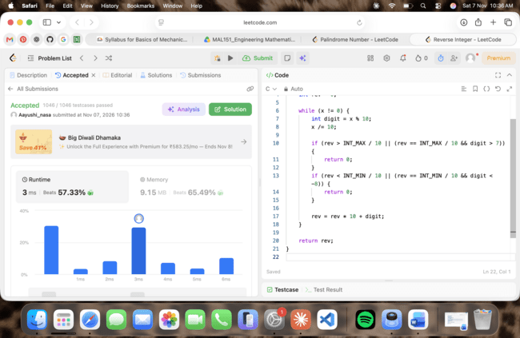

Question 23: 231. Power of Two
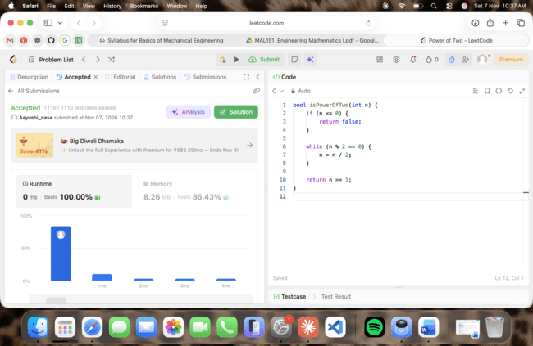

Question 24: 326. Power of Three
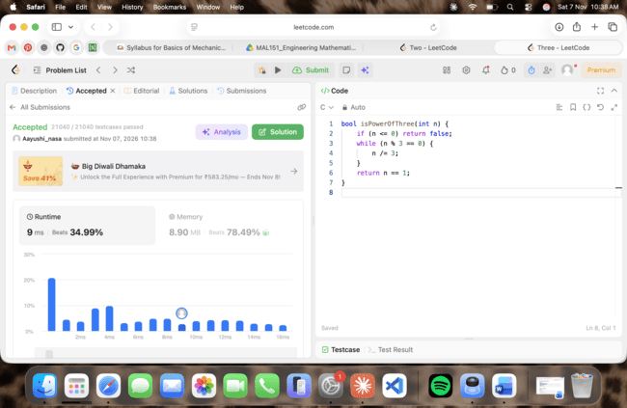

Question 25: Factorial
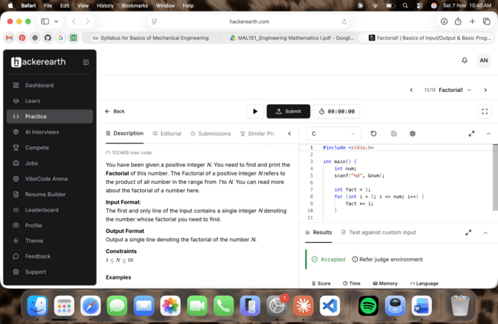

Question 26: Count Divisors
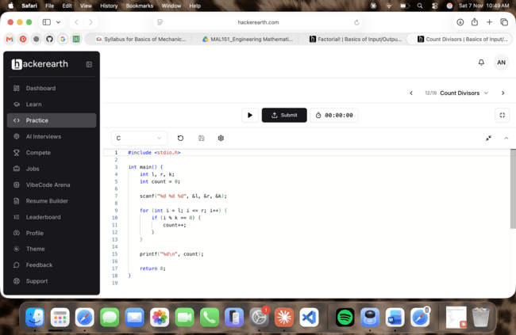

Question 27: Prime Numbers
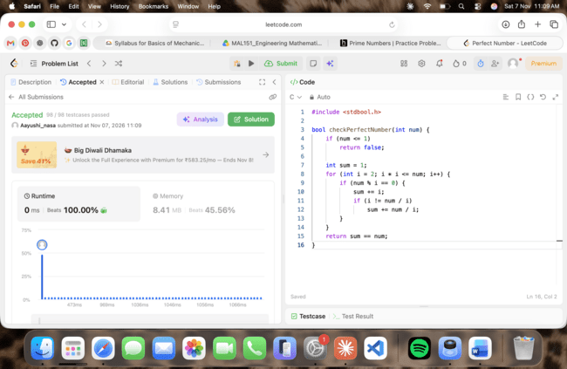

Question 28: Perfect Numbers
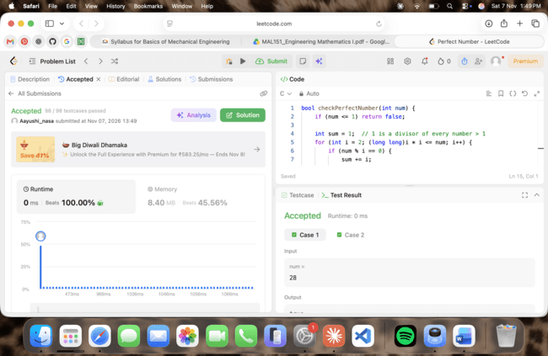

Question 29: Staircase
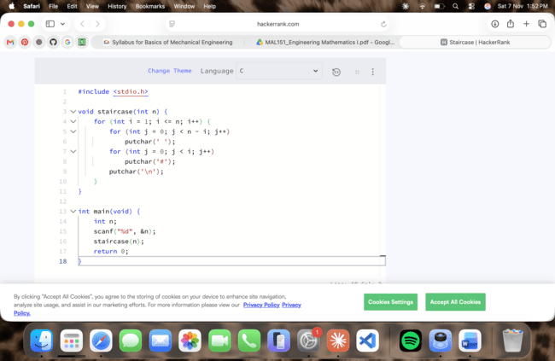

Question 30: Printing Pattern (concentric numbers)
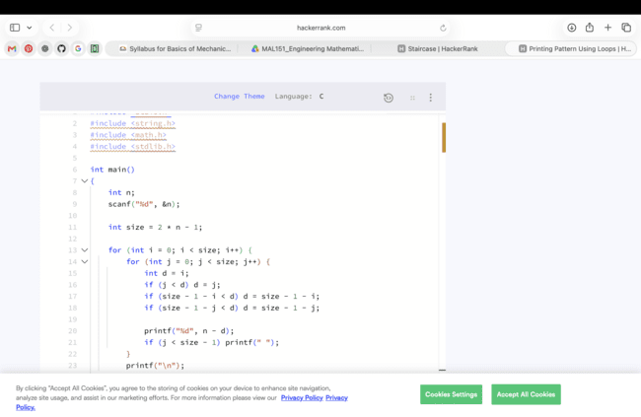

Question 31: Pattern: Square of Stars
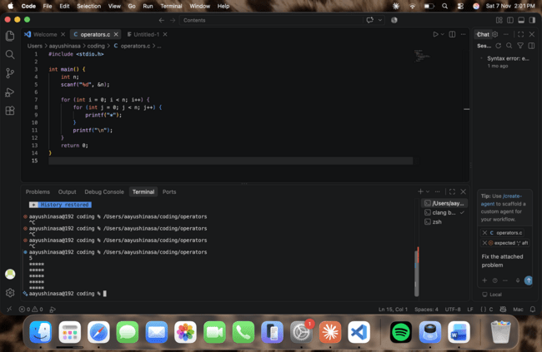

Question 32: Pattern: Right-Angled Triangle of Stars
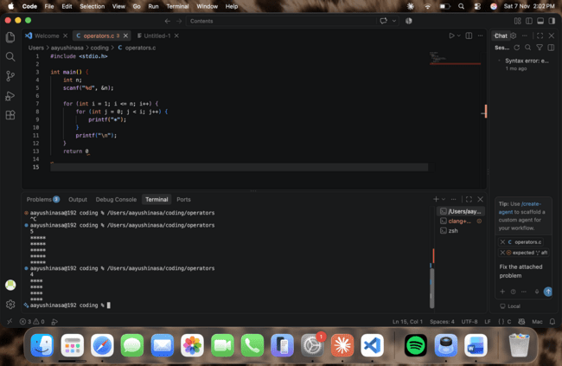

Question 33: Pattern: Inverted Right-Angled Triangle of Stars
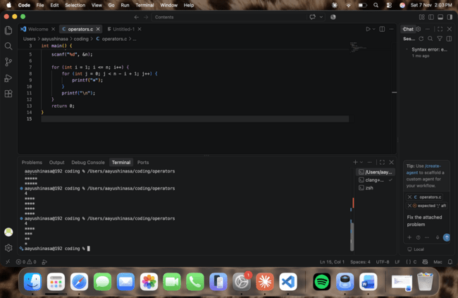

Question 34: Pattern: Number Triangle (1 2 3 ...)
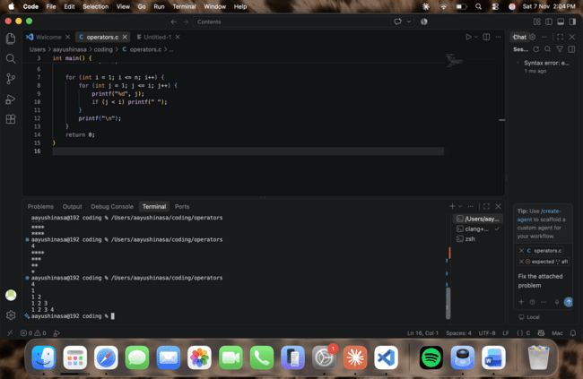

Question 35: Pattern: Row Number Triangle (1, 2 2, 3 3 3 ...)
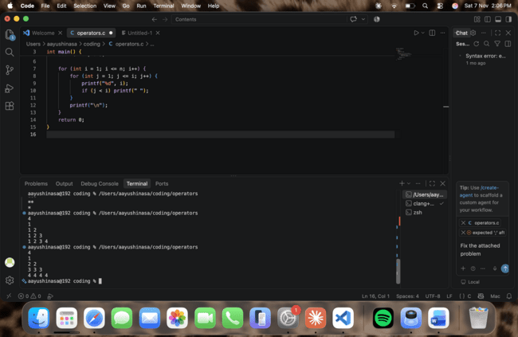
Question 36: Pattern: Floyd's Triangle
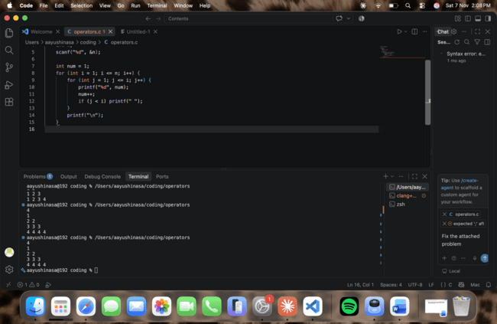

Question 37: Pattern: Right-Aligned Triangle of Stars
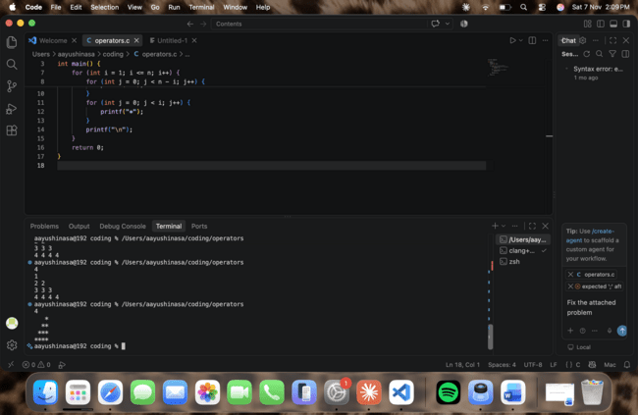

Question 38: Pattern: Pyramid of Stars
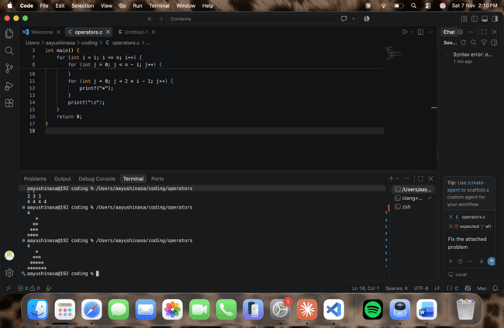

Question 39: Pattern: Inverted Pyramid of Stars
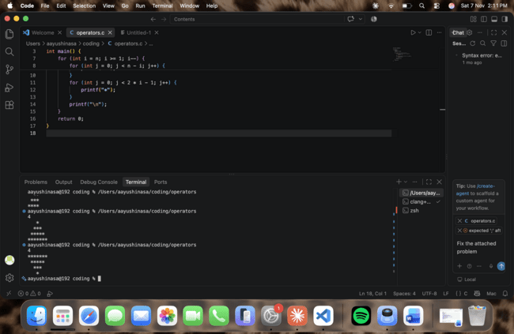

Question 40: Pattern: Hollow Square
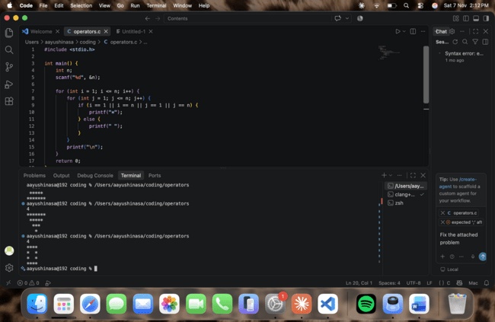

Question 41: Pattern: Hollow Right-Angled Triangle

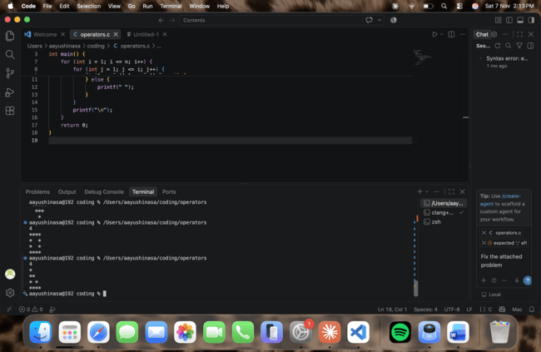

Question 42: Pattern: Multiplication Table
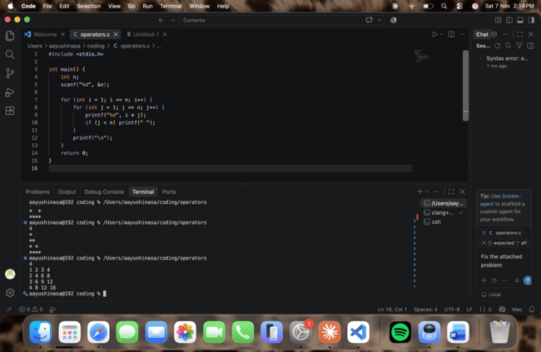

Question 43: Pattern: Checkerboard (X and O)
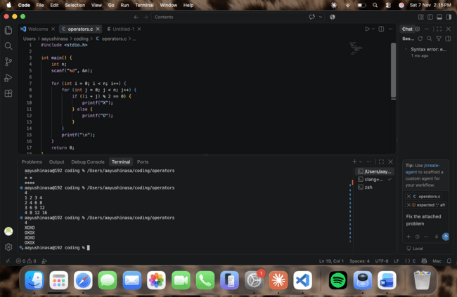

Question 44: Pattern: Floyd's Triangle (variant)
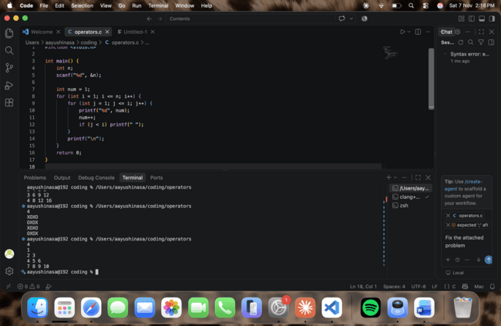

Question 46: Pattern: Butterfly


